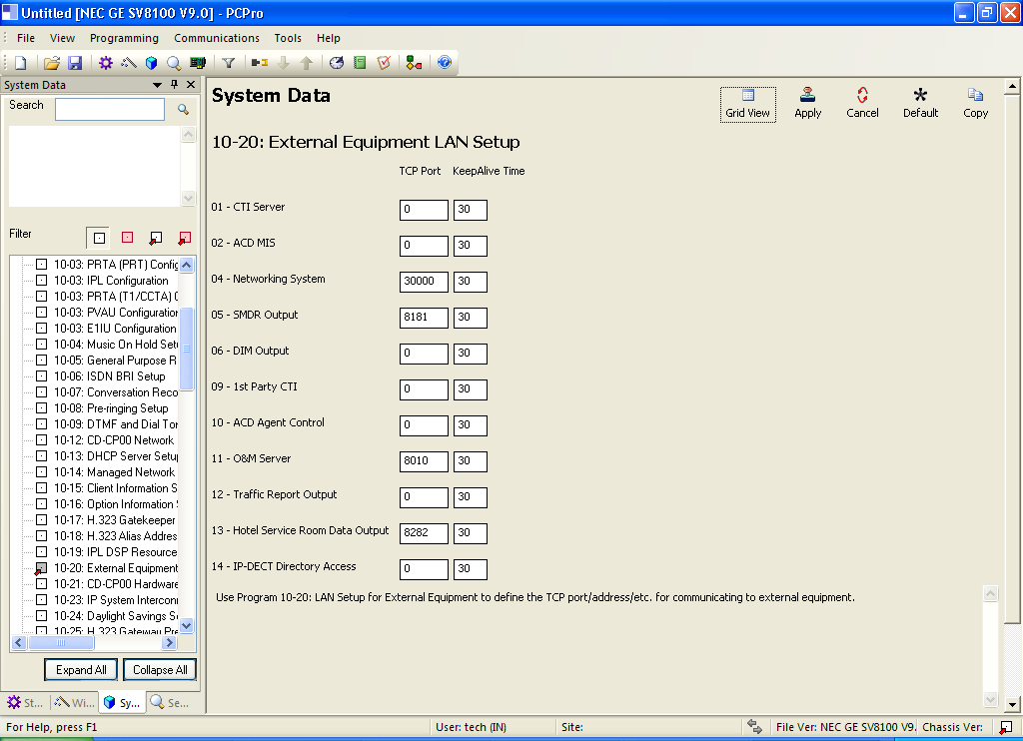

Tuk port

1. Smdr item 05
2. Room status item 13

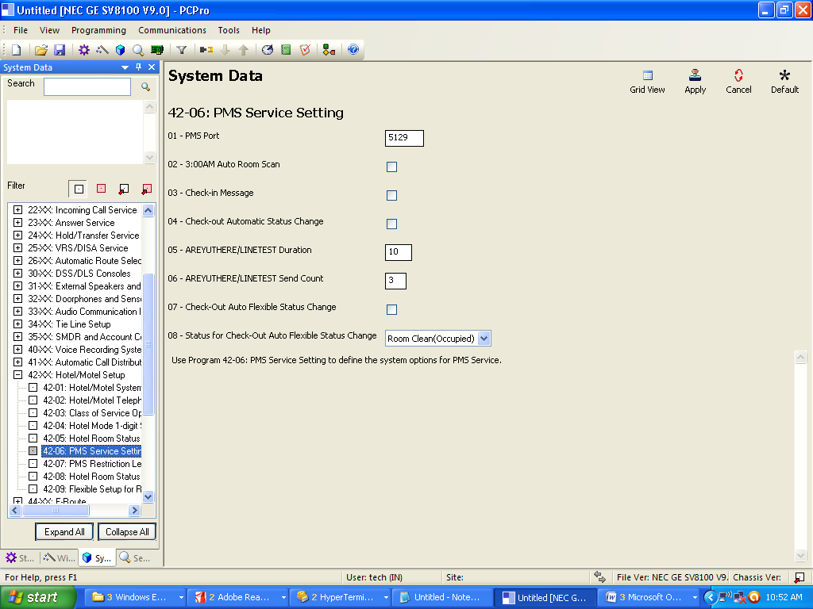

Port

1. Pms item 1

ROOM STATUS

Calling Class List -------- 21/05/2016 11:27

Room to Room Barring

Outside Call Class

208 -02, 209 -02

END

DND and Clean Up Check -------- 21/05/2016 11:27

Do No Disturb

208 , 209

Clean Up Check

END

Room Status List -------- 21/05/2016 11:27

Room Clean(Occupied) --- Check In

Room Clean(Vacant) --- Check Out

208 , 209

Maid Required

Maid in Room

Inspection Required

END

Room Status List -------- 21/05/2016 11:30

Room Clean(Occupied) --- Check In

Room Clean(Vacant) --- Check Out

208 , 209

Maid Required

Maid in Room

Inspection Required

END

Wake Up Call No Answered --- TEL No.208

Set Time11:30 No Ans Status Time Out

END

Calling Class List -------- 21/05/2016 11:31

Room to Room Barring

Outside Call Class

208 -02, 209 -02

END

DND and Clean Up Check -------- 21/05/2016 11:31

Do No Disturb

208 , 209

Clean Up Check

DND and Clean Up Check -------- 21/05/2016 11:31

Clean Up Check

END

Message Service List -------- 21/05/2016 11:31

END

Wake Up Call List -------- 21/05/2016 11:31

\*208 -11:30

END

Wake Up Call List -------- 21/05/2016 11:32

\*208 -11:30

END

Wake Up Call List -------- 21/05/2016 11:32

\*208 -11:30, 209 -11:50

END

Room Status List -------- 21/05/2016 11:37

Room Clean(Occupied) --- Check In

Room Clean(Vacant) --- Check Out

208 , 209

Maid Required

Maid in Room

Inspection Required

END

Calling Class List -------- 21/05/2016 11:37

Room to Room Barring

Outside Call Class

208 -02, 209 -02

END

DND and Clean Up Check -------- 21/05/2016 11:37

Do No Disturb

208 , 209

Clean Up Check

END

Message Service List -------- 21/05/2016 11:37

END

Wake Up Call List -------- 21/05/2016 11:37

\*208 -11:30, 209 -11:50

Wake Up Call List -------- 21/05/2016 11:37

END

DND and Clean Up Check -------- 21/05/2016 11:37

Do No Distu

208 , 209

Clean Up Check

END

Room Status List -------- 21/05/2016 11:38

Room Clean(Occupied) --- Check In

Room Clean(Vacant) --- Check Out

208 , 209

Maid Required

Maid in Room

Inspection Required

END

Calling Class List -------- 21/05/2016 11:38

Room to Room Barring

Outside Call Class

208 -02, 209 -02

END

DND and Clean Up Check -------- 21/05/2016 11:38

Do No Disturb

208 , 209

Clean Up Check

END

Message Service List -------- 21/05/2016 11:38

END

Wake Up Call List -------- 21/05/2016 11:38

\*208 -11:30, 209 -11:50

END

Wake Up Call List -------- 21/05/2016 11:40

\*208 -11:30, 209 -11:50

END

Wake Up Call List -------- 21/05/2016 11:40

\*208 -11:30, 209 -11:50

END

DATA MENTAH SMDR

CLASS TIME LINE DURATION STATION DIALLED No./CLI RD/COST ACCOUNT

01 POT 13:35 001 00:00:00 143

02 POT 13:37 001 00:00:00 143 0

03 POT 14:11 001 00:00:00 0 0

04 POT 14:11 002 00:00:00 0 0

05 POT 14:11 003 00:00:00 0 0

06 POT 14:11 004 00:00:00 0 0

07 POT 14:11 005 00:00:00 0 0

08 POT 14:11 006 00:00:00 0 0

09 POT 14:11 007 00:00:00 0 0

10 POT 14:11 008 00:00:00 0 0

11 POT 14:11 009 00:00:00 0 0

12 POT 14:11 010 00:00:00 0 0

13 POT 14:11 011 00:00:00 0 0

14 POT 14:11 009 00:00:00 0 0

15 POT 14:11 010 00:00:00 0 0

16 POT 14:11 011 00:00:00 0 0

17 POT 14:11 012 00:00:00 0 0

18 POT 14:11 013 00:00:00 0 0

19 POT 14:11 014 00:00:00 0 0

20 POT 14:11 015 00:00:00 0 0

21 POT 14:11 016 00:00:00 0 0

22 POT 14:11 017 00:00:00 0 0

23 POT 14:11 018 00:00:00 0 0

24 POT 14:11 019 00:00:00 0 0

25 POT 14:11 020 00:00:00 0 0

26 POT 14:11 019 00:00:00 0 0

27 POT 14:12 001 00:00:00 0 0

28 POT 14:12 004 00:00:00 0 0

29 POT 14:12 001 00:00:00 0 0

30 POT 14:12 001 00:00:00 0 08125387 0

31 PIN 14:12 001 00:00:28 0 0:14

32 POT 14:38 002 00:00:00 0 0

33 POT 14:38 001 00:00:00 0 0

34 POT 14:39 002 00:00:00 0 0

35 POT 14:39 003 00:00:00 0 0

36 POT 14:39 002 00:00:00 0 12 0

37 POT 14:39 001 00:00:00 0 0

38 PIN 15:23 020 0:30 NO ANSWER

39 POT 15:24 001 00:00:00 6900 0

40 POT 15:24 001 00:00:00 6900 021 0

41 POT 15:24 001 00:00:00 6900 02186 0

42 POT 15:25 001 00:00:00 6900 08158850730 0

43 POT 15:27 001 00:00:00 6900 08158850730 0

44 POT 15:27 001 00:00:00 6900 0214216339 0

45 POT 15:28 001 00:00:00 6900 0856846 0

46 POT 15:28 001 00:00:00 6900 08158850730 0

47 POT 15:28 001 00:00:00 6900 08158850730 0

48 BRD 15:29 001 00:00:00 143 421 0

49 POT 15:30 001 00:00:03 143 08158850730 0

50 POT 15:31 001 00:00:03 143 08158850730 0

51 POT 15:31 001 00:00:00 143 0214216339 0

52 BRD 15:32 001 00:00:00 143 02 0

53 BRD 15:32 001 00:00:00 6900 02 0

20/07/2015 PAGE 001

CLASS TIME LINE DURATION STATION DIALLED No./CLI RD/COST ACCOUNT

01 PIN 09:19 003 0:30 NO ANSWER

02 PIN 09:18 002 00:02:13 0

03 PIN 09:23 003 0:30 NO ANSWER

04 PIN 09:22 002 00:01:57 0 0:03

05 PIN 09:28 003 0:50 NO ANSWER

06 PIN 09:27 002 00:01:14 170 0:10

07 PIN 09:24 001 00:04:28 0 0:18

08 PIN 09:31 001 00:01:23 0 0:07

09 PIN 09:33 001 00:00:28 0 0:09

10 PIN 09:34 001 00:00:04 0 0:04

11 PIN 09:35 001 00:01:57 0 0:11

12 PIN 09:44 001 00:01:12 0 0:01

13 PIN 09:45 002 00:00:14 0 0:03

14 PIN 09:47 001 0:10 NO ANSWER

15 PIN 09:47 001 00:00:50 0 0:11

16 POT 09:54 019 00:00:00 0 37347 0

17 POT 09:54 020 00:01:19 0 373737 0

18 PIN 10:01 001 00:01:44 0 0:01

19 PIN 10:03 001 00:00:35 0 0:02

20 PIN 10:16 001 00:01:16 0 0:02

21 PIN 10:17 001 00:00:41 0 0:05

22 PIN 10:16 002 00:03:19 170 0:31

23 PIN 10:19 001 00:01:43 0 0:08

24 PIN 10:21 001 00:01:21 0 0:09

25 PIN 10:22 002 00:01:54 0 0:11

26 BRD 10:35 002 00:00:00 61606 5 0

27 PIN 10:35 001 00:00:40 0 0:11

28 BRD 10:37 001 00:00:00 61606 16 0

29 PIN 10:35 002 00:01:52 0 0:22

30 PIN 10:44 001 00:00:43 170 0:22

31 PIN 10:48 001 00:00:49 0 0:08